Creating And Setting Up SSH For GitHub
- Generating ssh key using command – Command: ssh-keygen -t ed25519 -C "your_email@example.com"
- Saving file with custom name
- Then press enter twice
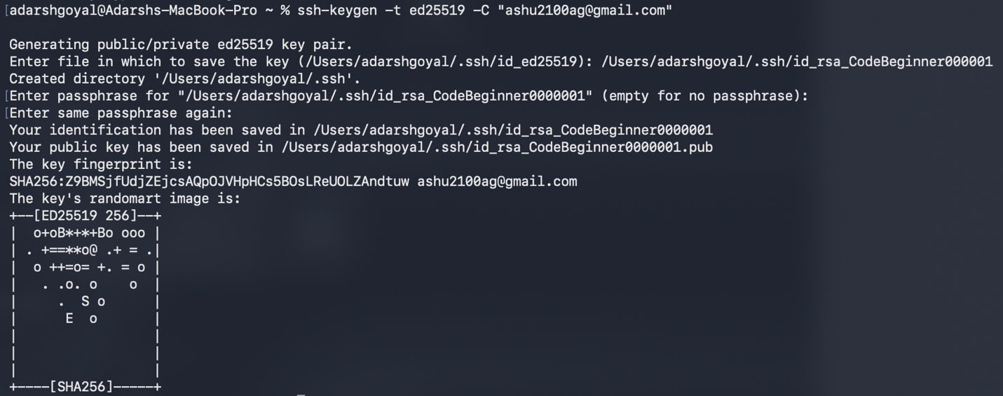
- Copy the generated SSH key from the file that is stored in ssh
Command: pbcopy < ~/.ssh/<ssh file name>.pub
- Login into account in github.com then pick on profile icon on the top right corner and select settings.

- Go to ssh and gpg key in the left side bar then click New SSH key green button.
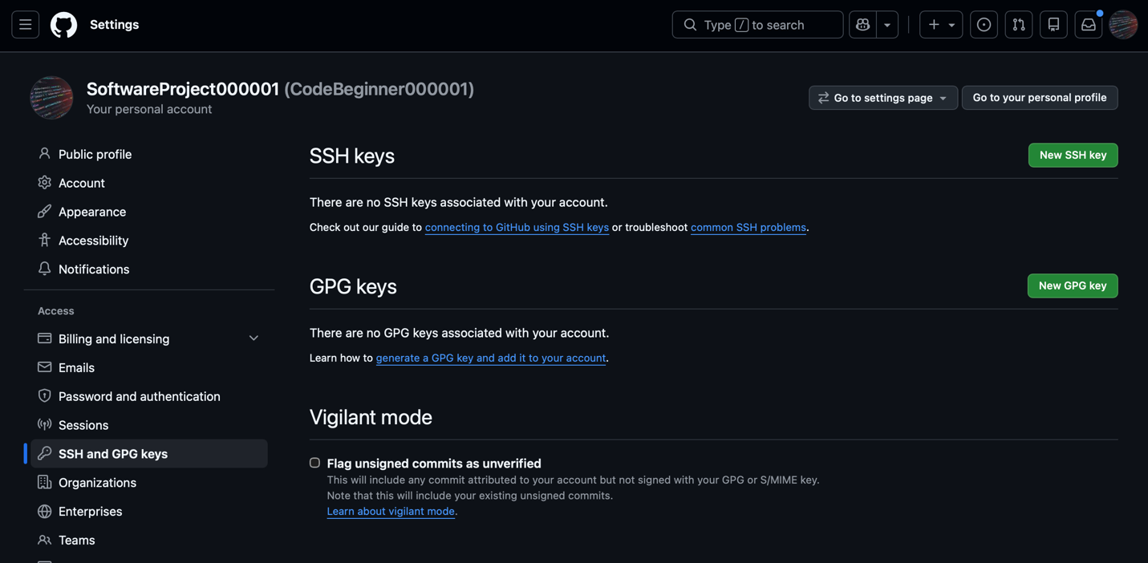
- Add name and the copied ssh key in their respective fields and click Add SSH Key button below the fields.
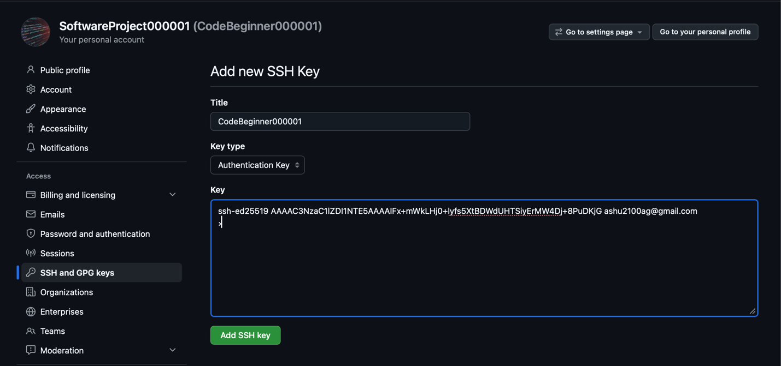
- Close window after successfully storing ssh key
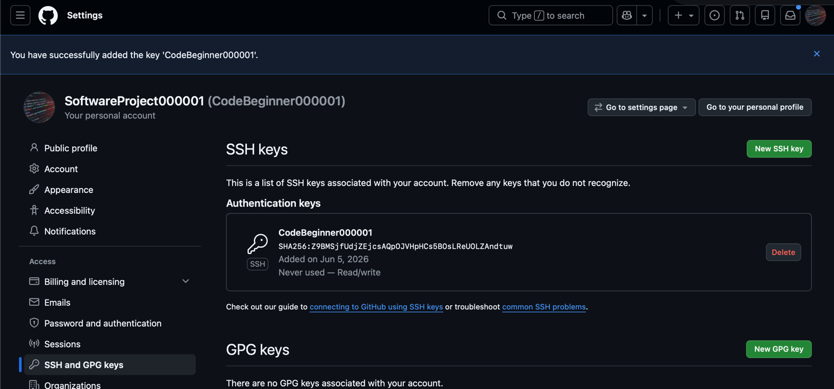
- Start the SSH-agent in the background to prevent having to type your passphrase every time you communicate with GitHub, add your key to the background.
Command: eval "$(ssh-agent -s)"
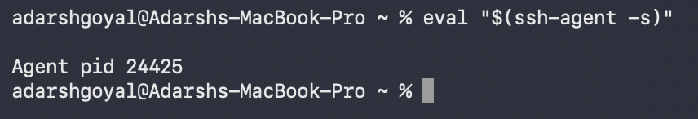
- Add your private SSH key to the agent
Command: ssh-add ~/.ssh/id_<ssh file name>
- Testing connection
Command: ssh -T git@github.com


